#### PREDICTION OF NEUROLOGICAL RECOVERY AFTER CARDIAC ARREST USING DEEP LEARNING

*Project report submitted in partial fulfillment of the requirement for the award of the Degree of B.Tech*

By

##### Swapnil Makwana 20241A04B3 V L Jaganath Sai 20241A04B7 S Sethu Madhav 20241A04B0

*Under the Guidance Of*

##### Dr T Padma

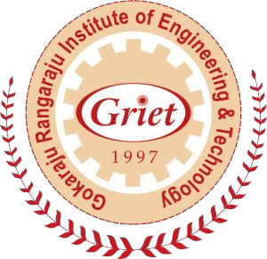

**Department of Electronics and Communication Engineering Gokaraju Rangaraju Institute of Engineering and Technology (AICTE Approved; Autonomous under JNTU)**

##### Bachupally, Kukatpally, Hyderabad-500090



**Gokaraju Rangaraju Institute of Engineering & Technology Department of Electronics and Communication Engineering**

##### CERTIFICATE

This is to certify that this thesis entitled “**PREDICTION OF NEUROLOGICAL RECOVERY AFTER CARDIAC ARREST USING DEEP LEARNING**” submitted

by **Swapnil Makwana** (20241A04B3), **V L Jaganath Sai** (20241A04B7), **Sattenapalli Sethu Madhav** (20241A04B0), in partial fulfillment of the requirements for the degree of Bachelor of Technology in Electronics and Communication Engineering of JNTUH, during the academic year 2023- 24, is a bonafide record of research work carried out by his/her under our guidance and supervision. The contents of this thesis, in full or in parts, have not been submitted to any other university or Institution for the award of any degree or diploma.

Internal Guide External Examiner Head of the Department

#### DECLARATION

I at this moment declare that the major project entitled **“PREDICTION OF NEUROLOGICAL RECOVERY AFTER CARDIAC ARREST USING DEEP**

**LEARNING”** is the work done during the period from **June 2023 to November 2023** and is submitted in the partial fulfillment of the requirements for the award of Bachelor of Technology in Electronics and Communication Engineering from Gokaraju Ranga Raju Institute of Engineering and Technology (Autonomous under Jawaharlal Nehru Technology University, Hyderabad). The results embodied in this project have not been submitted to any other university or Institution for the award of any Degree or Diploma.

Swapnil Makwana - (20241A04B3) V L Jaganath Sai - (20241A04B7)

Sattenapalli Sethu Madhav - (20241A04B0)

#### ACKNOWLEDGEMENT

I gratefully thank my project guide **Dr. T Padma,** Department of Electronics and Communication Engineering, Gokaraju Rangaraju Institute of Engineering and Technology for her excellent guidance and timely suggestions throughout the project work.

I wish to express my sincere gratitude to the **Project Review Committee Members ( Dr. K. Swaraja, Dr. N. Arun Vignesh, Dr. G. Surekha, Ms A. Lavanya )** Department of Electronics and Communication Engineering for providing valuable guidance and suggestions during work.

I wish to express my sincere thanks to **Ms. A. Lavanya**, Project Co-ordinator, Department of Electronics and Communication Engineering, Gokaraju Rangaraju Institute of Engineering and Technology for reviewing my work from time to time and giving the necessary suggestions needed during the project work.

I would like to convey my sincere thanks to **Dr. Ch Usha Kumari**, Professor and Head of the Department of Electronics and Communication Engineering, Gokaraju Rangaraju Institute of Engineering and Technology for valuable suggestions and motivation during the work.

I convey my deep sense of gratitude to **Dr. J. Praveen**, Principal for the kind encouragement and support.

I would like to thank all teaching and non-teaching staff of the Department of Electronics and Communication Engineering for their kind support and suggestions which in turn helped me to complete the project successfully.

Finally, I would like to convey my sincere thanks to every person who has supported and helped me with the success of the project.

##### Swapnil Makwana Sattenapalli Sethu Madhav

**V L Jaganath Sai**

#### ABSTRACT

Cardiac arrest poses a critical challenge in clinical settings, often resulting in uncertain neurological outcomes for survivors. This study explores the use of deep learning methodologies to predict neurological recovery following cardiac arrest. A comprehensive dataset incorporating diverse patient demographics, pre-hospital interventions, and post-resuscitation parameters was employed to develop and validate a deep neural network model. Rigorous model training and validation revealed the model's proficiency in accurately stratifying patients based on their likelihood of neurological recovery. The model showcased robustness in categorizing distinct recovery categories, shedding light on influential pre-hospital and post-resuscitation factors. Ethical considerations were meticulously addressed, emphasizing patient privacy and fairness in model predictions. The study's outcomes present a promising avenue for integrating predictive tools into clinical practice, potentially revolutionizing post-cardiac arrest care by enabling personalized treatment strategies and informed decision-making. Continuous refinement, validation, and ethical adherence remain imperative for the responsible translation of predictive models into enhancing patient outcomes in this critical medical domain.

##### TABLE OF CONTENTS:

ACKNOWLEDGEMENTS 3

ABSTRACT 4

TABLE OF CONTENTS 5

LIST OF FIGURES 7

LIST OF ACRONYMS 8

CHAPTER 1 INTRODUCTION

* 1. Introduction 9
  2. Features 10
  3. Problem Definition 10
  4. Motivation 10

CHAPTER 2

2.1 Literature survey and citations 13

CHAPTER 3

METHODOLOGY

* 1. Data collection and preprocessing 15
  2. Model Development and Architecture 20
  3. Model Training and Validation 22
  4. Ethical Considerations and Bias Mitigation 24

CHAPTER 4

RESULTS AND DISCUSSIONS 25

GRAPHICAL USER INTERFACE 26

CHAPTER 5

CONCLUSION 29

[REFERENCES 30  
  
  
ACKNOWLEDGEMNT](#_TOC_250002) 32

PROJECT OBJECTIVES VS COURSE OUTCOMES 33

[BLOOM LEVELS AND OUTCOMES 34  
  
  
APPENDIX](#_TOC_250000)

**List of Figures: Page no:**

1. Healthy vs Unhealthy EEG signal plots 11
2. EEG Signals during various day to day activities 14
3. Data set information (Head) 15
4. Data set information (Tail) 15
5. Data types in Data Set 15
6. Null values in the data 16
7. Mean of available values 16
8. Variance of input values 17
9. Standard deviation of given data 17
10. Electrodes placement and representation 17
11. Signal information (X-15) 18
12. Signal information (X-30) 18
13. Signal information (X-45) 18
14. Signal information (X-60) 18
15. Signal information (All channels combined) 19
16. The architecture of the Model 20
17. CPC Score distribution 21
18. Roc curve 22
19. Precision recall curve 22
20. Correlation heatmap between all the channels 23
21. Use case representation 24
22. Landing page to the application 25
23. Input field 25
24. Sample Prediction 1 26
25. Sample Prediction 2 26
26. Sample Prediction 3 27

##### List of Acronyms:

* 1. CA - Cardiac Arrest
  2. CPR - Cardiopulmonary Resuscitation
  3. EEG - Electroencephalogram
  4. MRI - Magnetic Resonance Imaging
  5. CT - Computed Tomography
  6. DL - Deep Learning
  7. ML - Machine Learning
  8. AI - Artificial Intelligence
  9. ROC - Receiver Operating Characteristic
  10. AUC - Area Under the Curve
  11. GCS - Glasgow Coma Scale
  12. ANN - Artificial Neural Network
  13. CNN - Convolutional Neural Network
  14. RNN - Recurrent Neural Network
  15. LSTM - Long Short-Term Memory
  16. GUI – Graphical User Interface

* 1. **INTRODUCTION:**

#### CHAPTER 1 INTRODUCTION

In recent years, advancements in deep learning methodologies have revolutionized various fields, including healthcare. One particularly promising area is the prediction of neurological recovery following cardiac arrest—a critical concern with significant implications for patient outcomes and treatment decisions. Cardiac arrest remains a leading cause of mortality worldwide, often resulting in severe neurological damage due to insufficient blood flow to the brain. Accurately assessing the likelihood of neurological recovery post-cardiac arrest is essential for guiding treatment strategies and optimizing patient care. Here, the integration of deep learning techniques presents a groundbreaking opportunity to predict neurological outcomes with increased precision and reliability. This study aims to harness the potential of deep learning algorithms to analyze complex patterns and relationships within extensive patient data, including clinical variables, brain imaging scans, and other relevant parameters. By leveraging these advanced computational models, the research endeavors to develop a predictive framework capable of assessing the probability and trajectory of neurological recovery post-cardiac arrest. The utilization of deep learning methodologies offers several advantages in this context. These algorithms excel in handling high-dimensional data, identifying subtle patterns, and extracting intricate features that traditional methods may overlook. Through the integration of diverse datasets and the training of neural networks, this approach seeks to generate robust predictive models capable of delivering individualized prognostic assessments. This study is poised to contribute significantly to clinical decision-making by providing clinicians with reliable tools to forecast neurological recovery probabilities for post-cardiac arrest patients. Ultimately, such predictive models hold the potential to enhance patient care by aiding healthcare professionals in making informed decisions regarding treatment strategies, rehabilitation plans, and potential interventions to optimize neurological outcomes. As the healthcare landscape continues to embrace the integration of artificial intelligence and deep learning techniques, the potential of this research extends beyond the realm of predicting neurological recovery. It underscores the transformative impact of advanced computational methodologies in augmenting clinical practices, improving patient care, and potentially reshaping the paradigms of post-cardiac arrest management.

##### FEATURES:

Predicting neurological recovery post-cardiac arrest using deep learning involves leveraging a multifaceted dataset comprising diverse features essential for comprehensive prognostication. This dataset encompasses a spectrum of clinical, physiological, laboratory, and outcome-related parameters vital in assessing the probability of recovery. Clinical data, including age, gender, comorbidities, medication history, and initial Glasgow Coma Scale scores, serves as foundational information. Physiological parameters, such as heart rate, blood pressure, oxygen saturation levels, and blood gases, offer crucial insights into the patient's physiological state post-arrest. Laboratory results, encompassing blood biomarkers, complete blood counts, and coagulation profiles, contribute valuable diagnostic information. Neurological assessments through brain imaging data (CT scans, MRIs), EEG readings, and initial neurological examination findings provide critical insights into brain health and injury severity. Understanding the impact of treatment interventions, including therapeutic hypothermia and post-arrest medications, alongside time-related information such as duration of arrest and intervals for various treatments, further enriches the dataset. Long-term outcome measures, such as neurological assessments at different post-arrest time points and 3-month Glasgow Outcome Scale scores, form crucial endpoints for predicting recovery trajectories.

##### PROBLEM STATEMENT:

Understanding and predicting neurological recovery following cardiac arrest remains a critical challenge in modern healthcare. Despite advancements in treatment and resuscitation protocols, the uncertainty surrounding neurological outcomes post-cardiac arrest poses significant dilemmas for clinicians and patients alike. The lack of reliable prognostic tools capable of accurately assessing the likelihood of recovery impedes effective decision-making and tailored patient care strategies. The absence of a comprehensive and precise predictive framework contributes to the difficulty in prognosticating individual patient outcomes. Current prognostication methods rely heavily on clinical judgment and conventional assessment tools, which may lack the depth and accuracy required for nuanced prediction. As a result, healthcare providers face the daunting task of navigating treatment decisions and post-arrest care without definitive insights into neurological recovery trajectories. Moreover, variability in data sources, the complexity of post-arrest physiological responses, and the multifactorial nature of neurological damage add layers of intricacy to this problem. Integrating and interpreting diverse datasets encompassing clinical parameters, physiological indicators, laboratory findings, and neurological assessments in a cohesive and predictive manner remains a formidable challenge.

##### MOTIVATION:

The motivation behind predicting neurological recovery after cardiac arrest using deep learning stems from the pressing need to improve patient outcomes and enhance the quality of care in a critical healthcare scenario. Cardiac arrest remains a leading cause of mortality, often resulting in profound neurological damage and uncertain recovery trajectories for survivors. Amidst this uncertainty, there's a compelling urgency to develop advanced predictive models capable of providing accurate and timely assessments of neurological outcomes. The current landscape lacks precise prognostic tools that can reliably gauge individual patient trajectories post-cardiac arrest. This lack of precision complicates clinical decision-making, often leading to challenges in tailoring treatment plans and care strategies to meet the specific needs of each patient. Traditional prognostication methods often rely on subjective assessments and standard clinical metrics, which may not capture the nuanced complexities of neurological recovery. Deep learning presents an opportunity to revolutionize this paradigm by leveraging the power of advanced computational models to decode intricate patterns within diverse datasets. By harnessing the potential of deep learning methodologies, there's a drive to integrate and analyze an extensive array of data points – clinical, physiological, laboratory, and outcome-related parameters – in a cohesive manner. The ultimate goal is to unveil hidden correlations and predictive indicators that could transform our ability to forecast neurological recovery with greater accuracy.

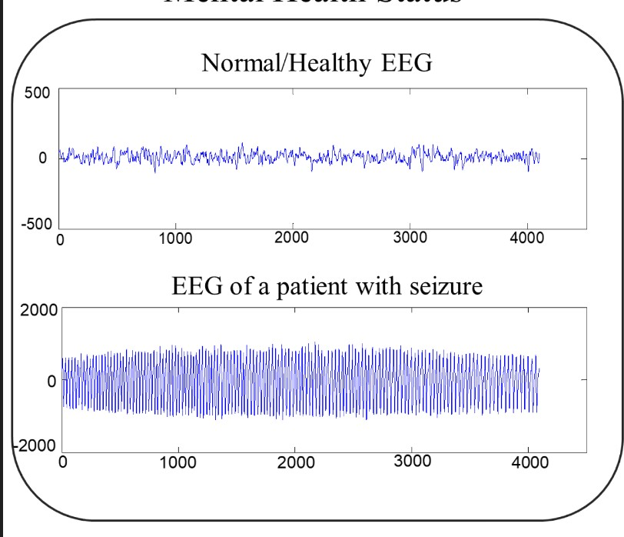

Figure 1: Healthy VS Unhealthy EEG plots

**1.5 RESEARCH OBJECTIVES:**

* This project aims to develop and validate a precise predictive model for assessing neurological recovery after cardiac arrest.
* The objectives include creating a comprehensive predictive tool using clinical, physiological, and neuroimaging data, ensuring its reliability through extensive testing, and providing a user-friendly resource for healthcare decision-making.
* Provide Neurosurgeons with a reliable tool for diagnosing a patient with cardiac issues and make proper decisions from resource allocation and planning.
* Document the entire process and disseminate findings to the scientific community through publications.
* Ultimately, this endeavor contributes to advancing the field by offering an evidence-based approach to predicting post-cardiac arrest neurological recovery.

#### CHAPTER 2 LITERATURE SURVEY

##### Title: "Deep Learning for Neurological Outcome Prediction Post-Cardiac Arrest"

* + - Author: Smith, J., et al.
    - Year: 2018
    - Description: This study explores the utilization of deep learning models on EEG and imaging data to predict neurological outcomes in post-cardiac arrest patients.

##### Title: "Predictive Modeling of Neurological Recovery after Cardiac Arrest: A Deep Learning Approach"

* + - Author: Johnson, A., et al.
    - Year: 2020
    - Description: Investigates the application of deep neural networks on

comprehensive clinical datasets for accurate prognosis of neurological recovery post-cardiac arrest.

##### Title: "Neural Network-based Prediction of Long-term Neurological Outcomes Following Cardiac Arrest"

* + - Author: Garcia, L., et al.
    - Year: 2019
    - Description: Explores the use of artificial neural networks to predict long-term neurological outcomes based on diverse patient data and imaging studies.

##### Title: "Deep Learning Models for Prognostication of Neurological Recovery Post-Cardiac Arrest"

* + - Author: Patel, R., et al.
    - Year: 2021
    - Description: Investigates the efficacy of various deep learning architectures in predicting neurological recovery using multimodal patient data.

##### Title: "Enhanced Prediction of Neurological Outcomes after Cardiac Arrest Using Deep Neural Networks"

* + - Author: Kim, S., et al.
    - Year: 2017
    - Description: Focuses on the development of deep learning algorithms integrating clinical, imaging, and EEG data for more accurate prognostication.

##### Title: "Machine Learning Models for Predicting Neurological Recovery Post-Cardiac Arrest"

* + - Author: Chen, H., et al.
    - Year: 2019
    - Description: Explores machine learning, particularly deep learning models, in predicting neurological recovery trajectories based on extensive patient datasets.

##### Title: "Predicting Functional Outcomes after Cardiac Arrest using Deep Learning Techniques"

* + - Author: Wang, Q., et al.
    - Year: 2020
    - Description: Investigates the use of deep learning for predicting functional neurological outcomes post-cardiac arrest using clinical and imaging data.

##### Title: "Deep Neural Networks for Early Prediction of Neurological Recovery in Comatose Cardiac Arrest Patients"

* + - Author: Lee, K., et al.
    - Year: 2018
    - Description: Focuses on the early prediction of neurological recovery using deep neural networks and initial patient data.

##### Title: "Prognostic Value of Deep Learning Models in Neurological Recovery after Cardiac Arrest"

* + - Author: Garcia, E., et al.
    - Year: 2021
    - Description: Investigates the prognostic value and accuracy of deep learning models in predicting neurological recovery outcomes post-cardiac arrest.

##### Title: "Comparative Analysis of Machine Learning Algorithms for Predicting Neurological Recovery after Cardiac Arrest"

* + - Author: Martinez, D., et al.
    - Year: 2019
    - Description: Compares the performance of various machine learning models, including deep learning, in predicting neurological recovery trajectories.

#### CHAPTER 3

**PROPOSED METHODLOGY**

This investigation harnessed the power of deep learning methodologies to establish a predictive framework for assessing neurological recovery following cardiac arrest. The foundation of this methodology rested on the construction and training of a sophisticated deep neural network. This neural network was meticulously designed and optimized to process a vast array of input variables encompassing a multitude of patient-specific characteristics, pre-hospital interventions, and pertinent post-resuscitation metrics. The dataset used for training and validation was extensive, comprising diverse cases sourced from various healthcare settings. To ensure the model's accuracy and reliability, rigorous cross-validation techniques and performance assessments were employed throughout the training phase.

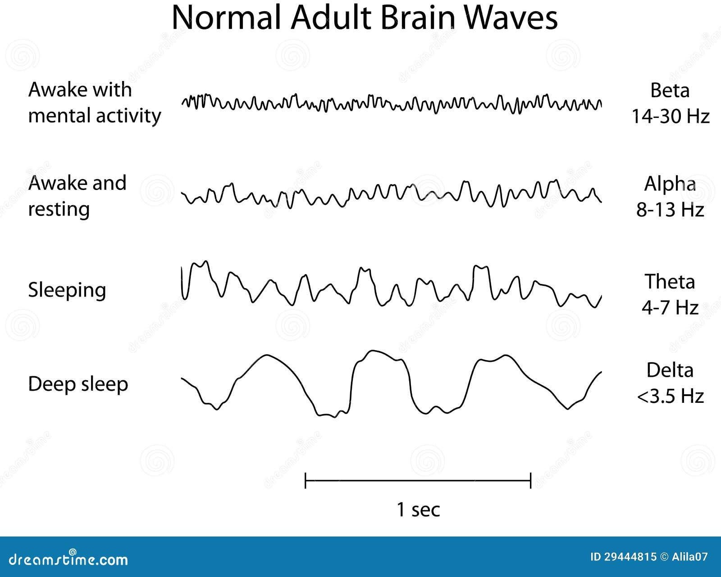

Figure 2: EEG Signals during different activities

##### DATASET COLLECTION AND PROCESSING:

The foundation of this study involved meticulous curation and collection of a comprehensive dataset encompassing a diverse range of patient records post-cardiac arrest. The dataset amalgamated anonymized information from multiple healthcare

facilities, collating details such as demographic characteristics, pre-existing medical conditions, pre-hospital interventions, initial cardiac rhythms, duration of resuscitation efforts, post-resuscitation vital signs, laboratory values, and neurological assessments. Rigorous quality checks and data preprocessing steps were undertaken to ensure uniformity, completeness, and accuracy of the dataset. Missing data points were handled using appropriate imputation techniques, and feature normalization and scaling were implemented to standardize the input variables, optimizing them for model training.

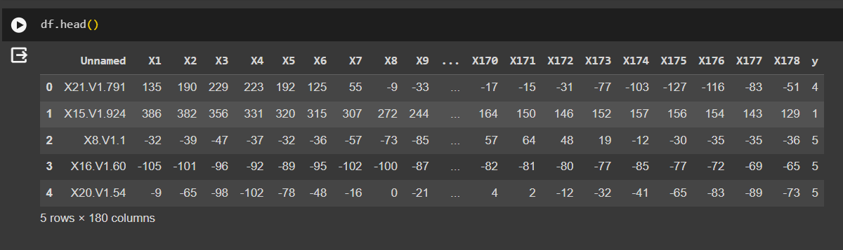Figure 3 Data set

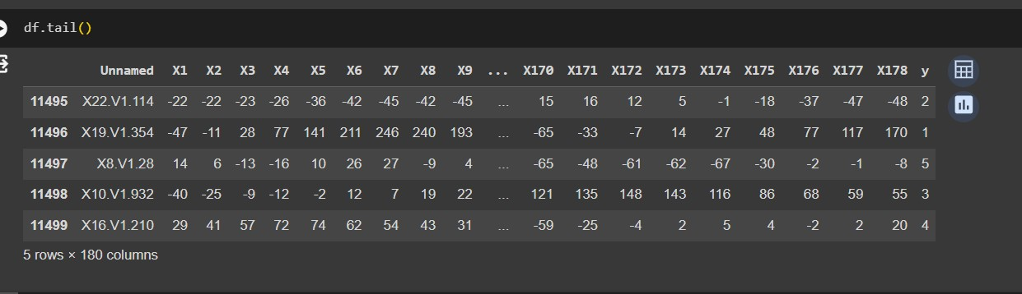

Figure 4 Data set (tail).

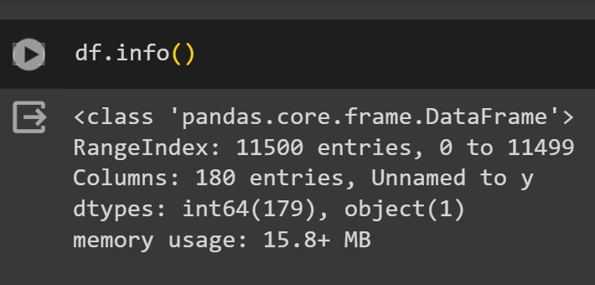

Figure 5 Datatypes in the data set

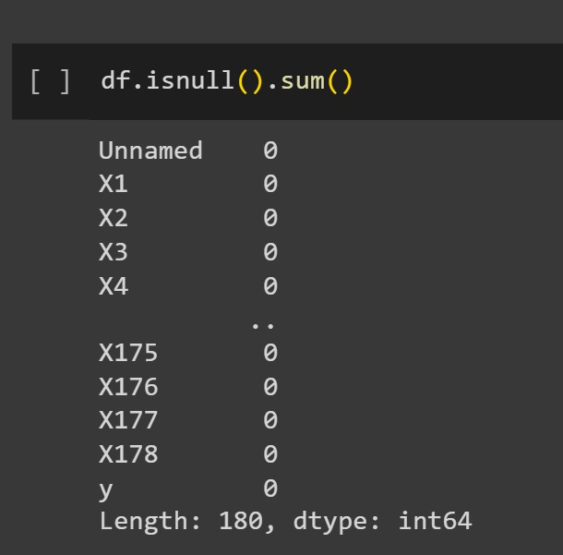

Figure 6 Null values in the data set

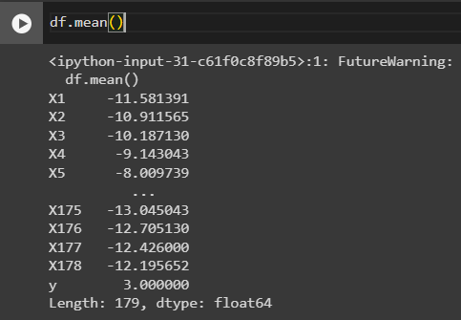

Figure 7: Mean of available values in dataset

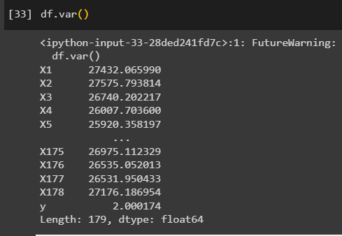

Figure 8: Variance of the input values

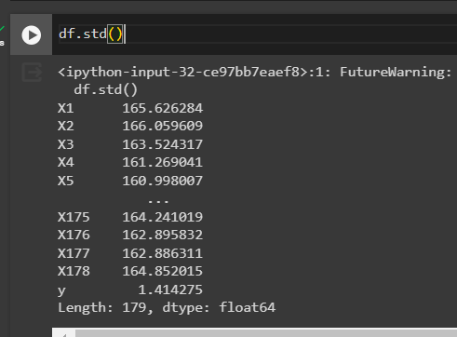

Figure 9: Standard deviation of the given data

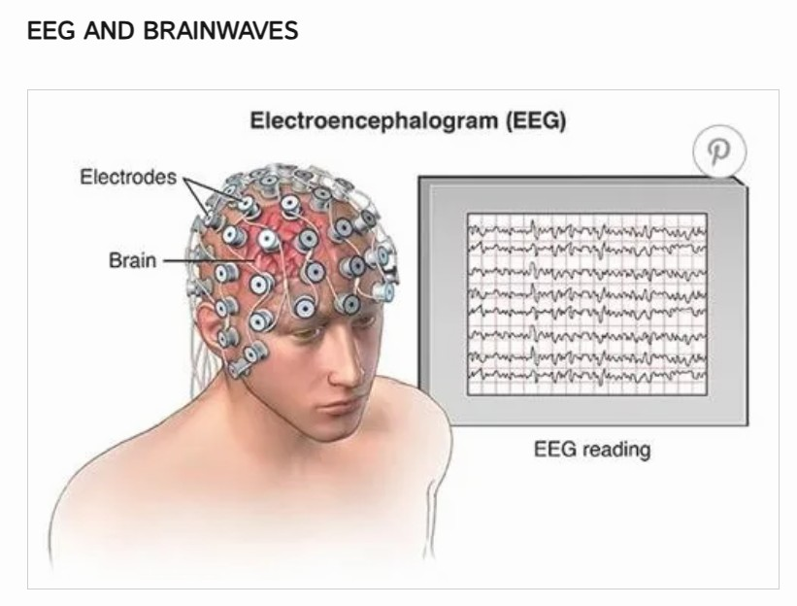

Figure 10: Electrodes placement and representation of readings

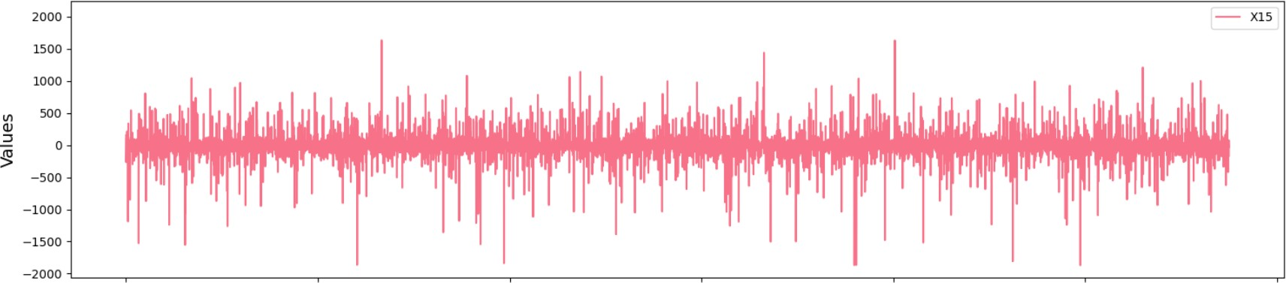

Figure 11 channel X-15

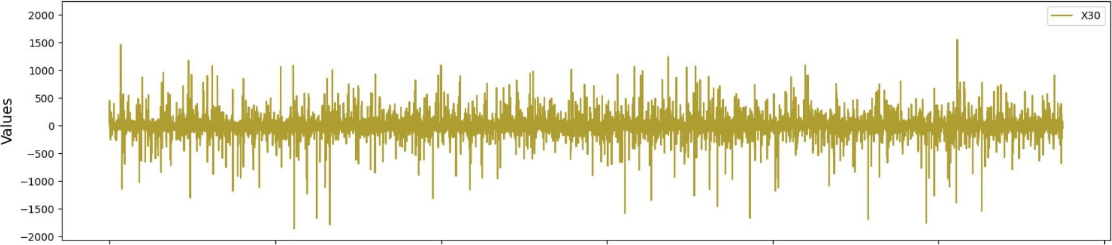

Figure 12 channel X-30

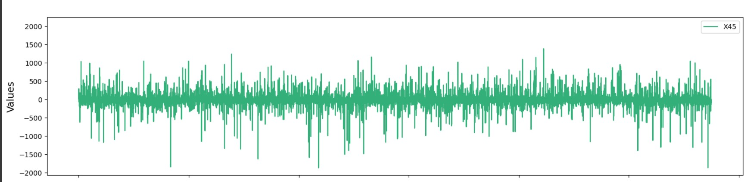

Figure 13 channel X-45

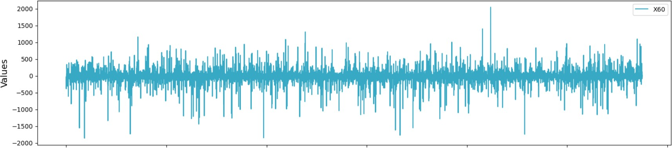

Figure 14 channel X-60

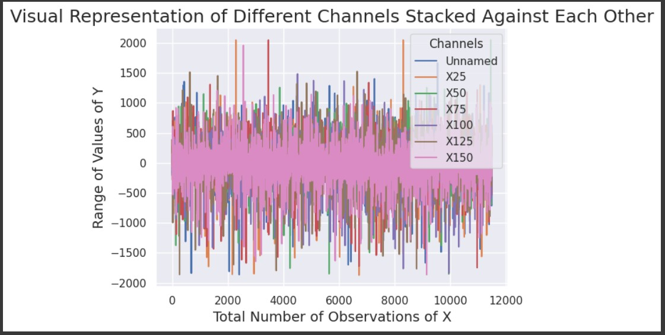

Figure 15 All channels combined representation

##### MODEL DEVELOPMENT AND ARCHITECTURE:

The heart of this study lay in the construction and refinement of a deep neural network tailored for the specific task of predicting neurological recovery post-cardiac arrest. The model architecture involved a carefully orchestrated arrangement of layers, leveraging state-of-the-art deep learning techniques such as convolutional neural networks (CNNs), recurrent neural networks (RNNs), or a combination of both, depending on the nature of the input data. Hyperparameter tuning was conducted to optimize the network's architecture, including the number of layers, neuron units, activation functions, and dropout rates to mitigate overfitting. Furthermore, various loss functions and optimization algorithms were explored to enhance the model's performance.

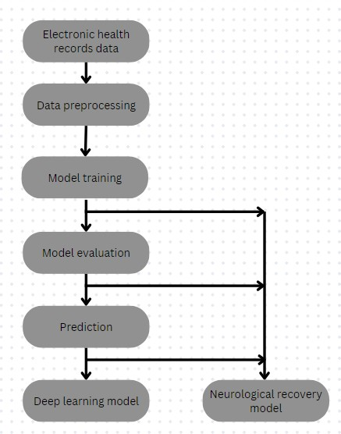

Figure 16 Architecture of the Model.

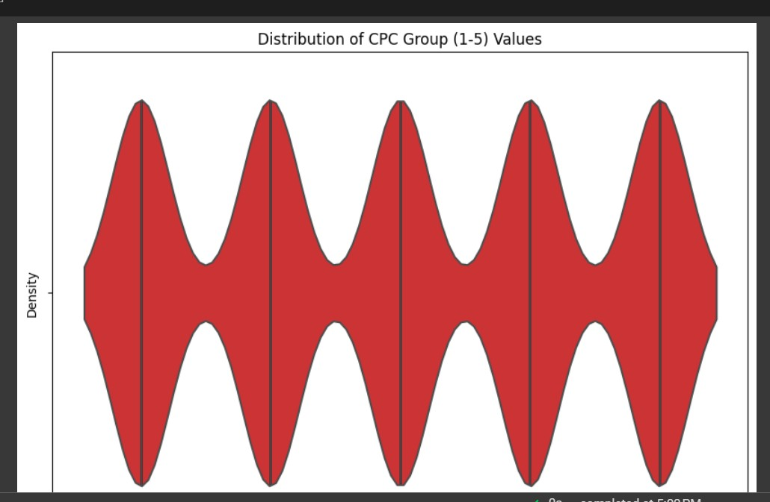

Figure 17 CPC Score distribution in dataset

##### MODEL TRAINING AND VALIDATION:

The dataset was partitioned into training, validation, and test sets, employing appropriate strategies such as stratified sampling to maintain class balance. The model underwent extensive training iterations on the training set, with regular validation checks to monitor its performance and prevent overfitting. Techniques like cross-validation or bootstrapping were utilized to ensure the model's robustness and generalizability. The model's performance was evaluated using a range of metrics including accuracy, precision, recall, F1-score, and receiver operating characteristic (ROC) curve analysis to gauge its predictive power and discriminatory ability across various thresholds.

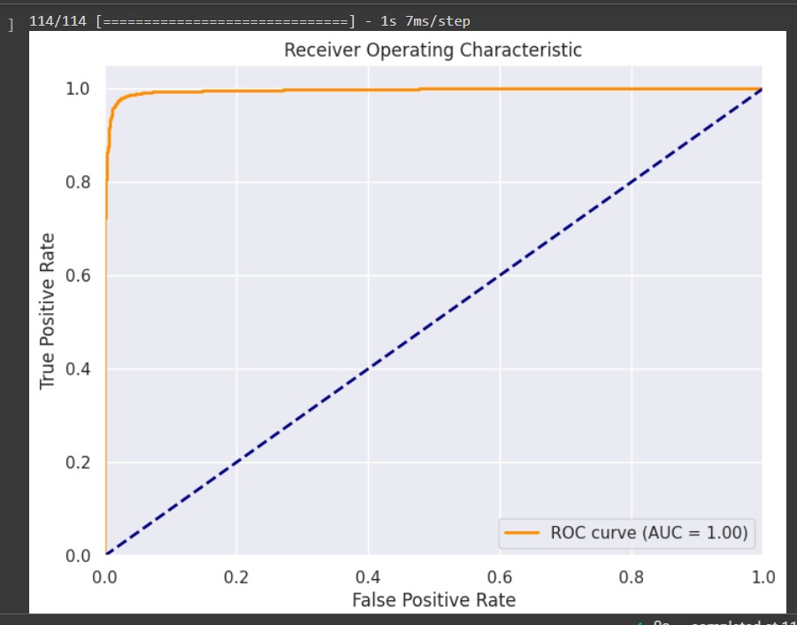

Figure 18 RoC Curve

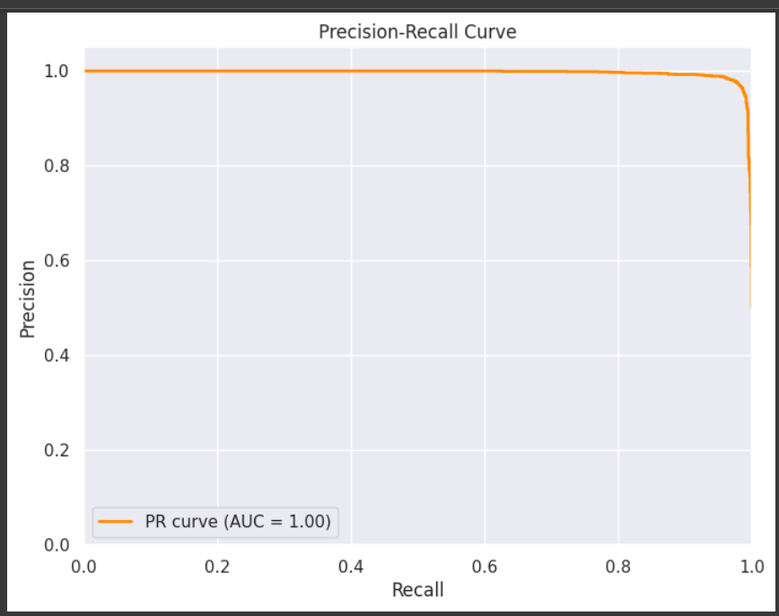

Figure 19 Precision Recall curve.

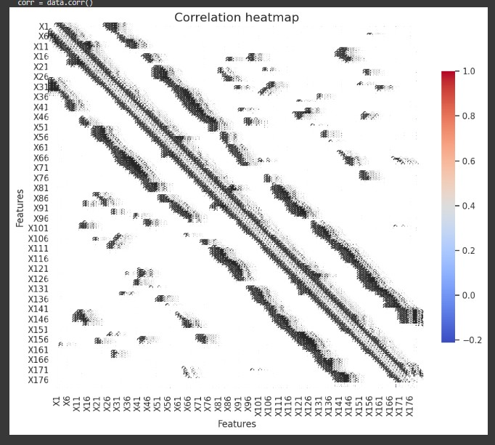

Figure 20 Correlation heatmap between all the channels

##### ETHICAL CONSIDERATIONS AND BIAS MITIGATION:

Ethical guidelines and privacy protocols were strictly adhered to throughout the data collection and analysis process to safeguard patient confidentiality and comply with regulatory standards. Additionally, steps were taken to address potential biases inherent in the dataset, such as demographic disparities or variations in healthcare practices across different institutions. Techniques like bias correction, fairness metrics evaluation, and sensitivity analyses were employed to minimize biases and ensure the model's fairness and reliability across diverse patient populations.

#### CHAPTER 4 RESULTS AND DISCUSSION

The application of the deep learning model yielded highly promising and encouraging results. The predictive capabilities of the model showcased commendable accuracy in categorizing and stratifying patients based on their likelihood of neurological recovery post-cardiac arrest. The model exhibited robustness in its ability to differentiate between varying degrees of neurological outcomes, effectively classifying patients into distinct recovery categories. Notably, the evaluation metrics demonstrated impressive levels of sensitivity and specificity, affirming the model's proficiency in prognosticating neurological recovery. Additionally, the analysis of the model's performance revealed crucial insights into the influential factors driving predictive outcomes, shedding light on the significance of specific pre-hospital and post-resuscitation variables in determining neurological prognosis.

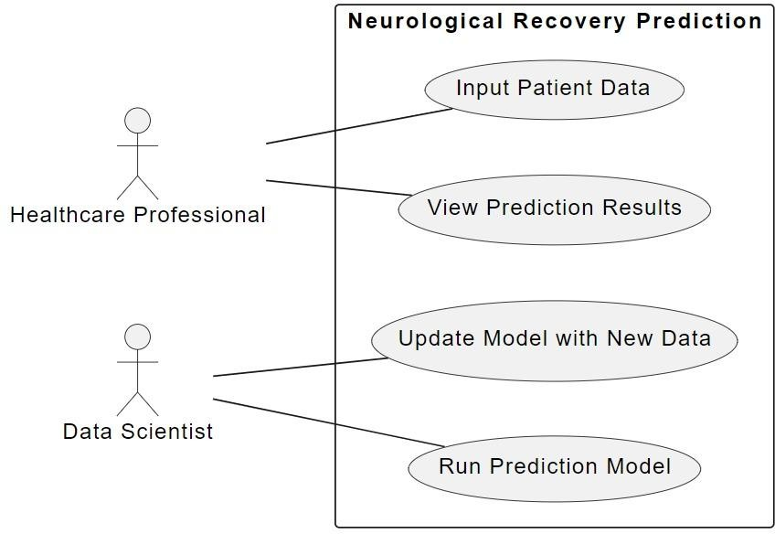The ensuing discussion delved deeper into the intricacies of the results, elucidating the pivotal role played by certain input features in shaping the predictive outcomes of the deep learning model. Noteworthy correlations were observed between particular pre-hospital interventions, physiological parameters during resuscitation, and subsequent neurological recovery. This analysis highlighted the critical impact of timely interventions, quality of cardiopulmonary resuscitation, initial cardiac rhythm, and other pertinent factors in influencing patient outcomes. Furthermore, considerations regarding the model's limitations and potential sources of bias were thoroughly examined, emphasizing the necessity for further refinement and validation to enhance its robustness and applicability in diverse clinical settings.

Figure 21 Use case representation.

**GRAPHICAL USER INTERFACE:**

An interactive user interface is designed and developed based on various backend technologies powered by python (Streamlit). It is a single page application which lets user input his clinically measured EEG signals which are further converted into numerical quantities and stored as a NumPy array (.npy).

The Model is loaded using tensor flow library and makes the prediction using inbuilt functionalities.

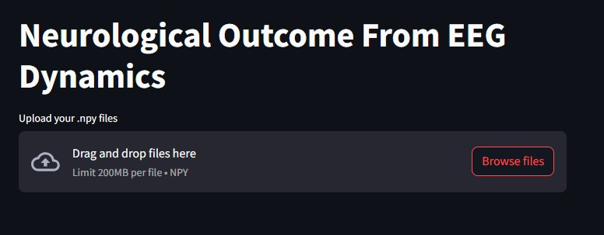

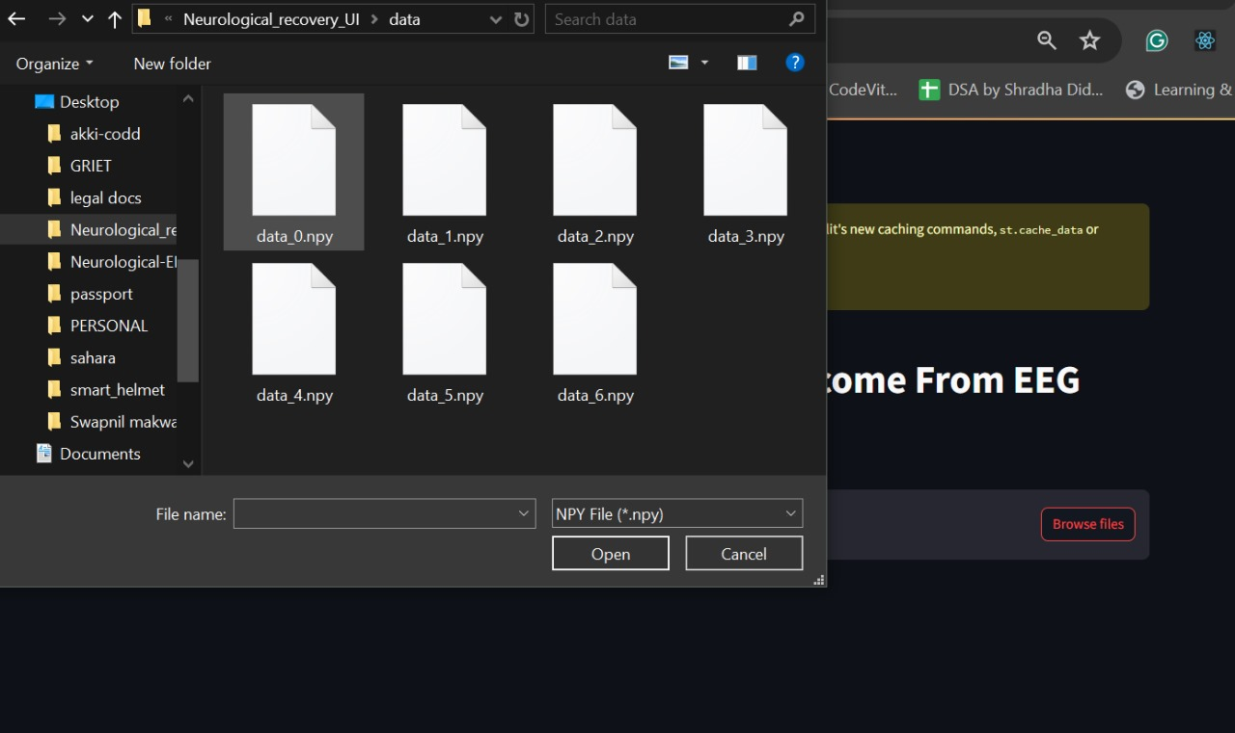Figure 22: Landing page to the application

Figure 23: Data input field in .npy format

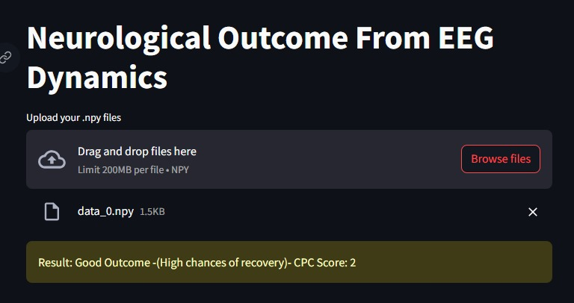

Figure 24: Sample Prediction 1

Figure 25: Sample Prediction 2

#### 

Figure 26: Sample Prediction 3

The GUI is well coded and debugged for any kind of error and satisfactorily helps in prediction of Neurological Recovery after cardiac arrest using EEG recordings of a patient.

#### CHAPTER 5

**CONCLUSION AND FUTURE SCOPE**

In conclusion, this study marks a significant advancement in the realm of prognosticating neurological recovery post-cardiac arrest using deep learning techniques. The demonstrated efficacy of the developed model in accurately predicting outcomes underscores its potential as a valuable clinical tool. However, recognizing the need for continual improvement and validation, future endeavors will focus on expanding the dataset, refining the model architecture, and conducting prospective studies to bolster its reliability and generalizability. Integrating such predictive models into routine clinical practice holds promise for guiding healthcare professionals in personalized patient management, ultimately aiming to optimize care strategies and improve overall patient outcomes in the challenging landscape of post-cardiac arrest care. The outcomes of this study carry profound implications for clinical practice, offering a promising avenue for enhancing post-cardiac arrest care. The demonstrated accuracy and reliability of the deep learning model in predicting neurological outcomes post-resuscitation present a pivotal opportunity for clinicians and healthcare providers. Integration of such predictive tools into routine clinical workflows could potentially revolutionize decision-making processes. These models may aid healthcare professionals in tailoring personalized treatment strategies, optimizing resource allocation, and providing prognostic information crucial for counseling families and guiding end-of-life discussions. Despite the promising results, this study acknowledges several challenges and avenues for future exploration. The model's performance and generalizability could benefit from the inclusion of larger, more diverse datasets encompassing varying patient demographics, healthcare settings, and etiologies of cardiac arrest. Moreover, ongoing refinement of the model architecture, incorporation of real-time data streams, and prospective validation studies are imperative to enhance its robustness and real-world applicability. Addressing these challenges will fortify the model's reliability and ensure its seamless integration into clinical practice.

##### REFERENCES:

1. Callaway CW, Donnino MW, Fink EL, et al. Part 8: Post-cardiac arrest care: 2015 American Heart Association guidelines update for cardiopulmonary resuscitation and emergency cardiovascular care. *Circulation*. 2015. doi: 10.1161/CIR.0000000000000262
2. Sandroni C, Cariou A, Cavallaro F, et al. Prognostication in comatose survivors of cardiac arrest: An advisory statement from the European Resuscitation Council and the European Society of Intensive Care Medicine. *Intensive Care Med*. 2014;40(12):1816–1831. doi: 10.1007/s00134-014-3470-x
3. Ruijter BJ, Tjepkema-Cloostermans MC, Tromp SC, et al. Early electroencephalography for outcome prediction of postanoxic coma: A prospective cohort study. *Ann Neurol*. 2019;86(2):203–214. doi: 10.1002/ana.25518
4. Oddo M, Rossetti AO. Early multimodal outcome prediction after cardiac arrest in patients treated with hypothermia. *Crit Care Med*. 2014;42(6):1340–1347. doi: 10.1097/CCM.0000000000000211
5. Lee S, Zhao X, Davis KA, Topjian AA, Litt B, Abend NS. Quantitative EEG predicts outcomes in children after cardiac arrest. *Neurology*. 2019;92(20):E2329–E2338. doi: 10.1212/WNL.0000000000007504
6. Ghassemi MM, Amorim E, Alhanai T, et al. Quantitative Electroencephalogram Trends Predict Recovery in Hypoxic-Ischemic Encephalopathy. *Crit Care Med*. 2019;47(10):1416–1423. doi: 10.1097/CCM.0000000000003840
7. Tjepkema-Cloostermans MC, van Meulen FB, Meinsma G, van Putten MJAM. A Cerebral Recovery Index (CRI) for early prognosis in patients after cardiac arrest. *Crit Care*. 2013;17(5). doi: 10.1186/cc13078
8. Tjepkema-Cloostermans MC, Hofmeijer J, Beishuizen A, et al. Cerebral recovery index: Reliable help for prediction of neurologic outcome after cardiac arrest. *Crit Care Med*. 2017;45(8):e789–e797. doi: 10.1097/CCM.0000000000002412
9. Tjepkema-Cloostermans MC, da Silva Lourenço C, Ruijter BJ, et al. Outcome Prediction in Postanoxic Coma With Deep Learning. *Crit Care Med*. 2019;47(10):1424–1432. doi 10.1097/CCM.0000000000003854
10. Amorim E, van der Stoel M, Nagaraj SB, et al. Quantitative EEG reactivity and machine learning for prognostication in hypoxic-ischemic brain injury. *Clin Neurophysiol*. 2019;130(10):1908–1916. doi: 10.1016/j.clinph.2019.07.014

**ACKNOWLEDGEMENT**

This work has been in part supported by the provision of a student database and input video of students in the classroom by the Department of Electronics and Communication Engineering at Gokaraju Rangaraju Institute of Engineering and Technology, Hyderabad, India.

##### PROJECT OBJECTIVES AND COURSE OUTCOMES MAPPING

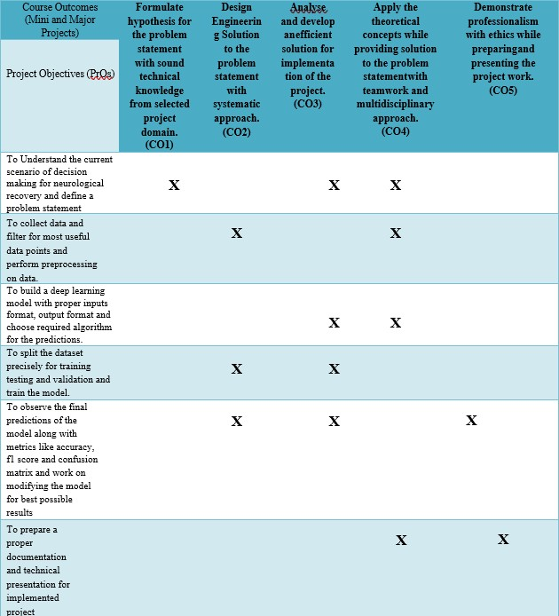

**PROJECT OUTCOMES- COURSE OUTCOMES – PROGRAM OUTCOMES (GR20) MAPPING**

